Dr. Ian McCulloh Biography
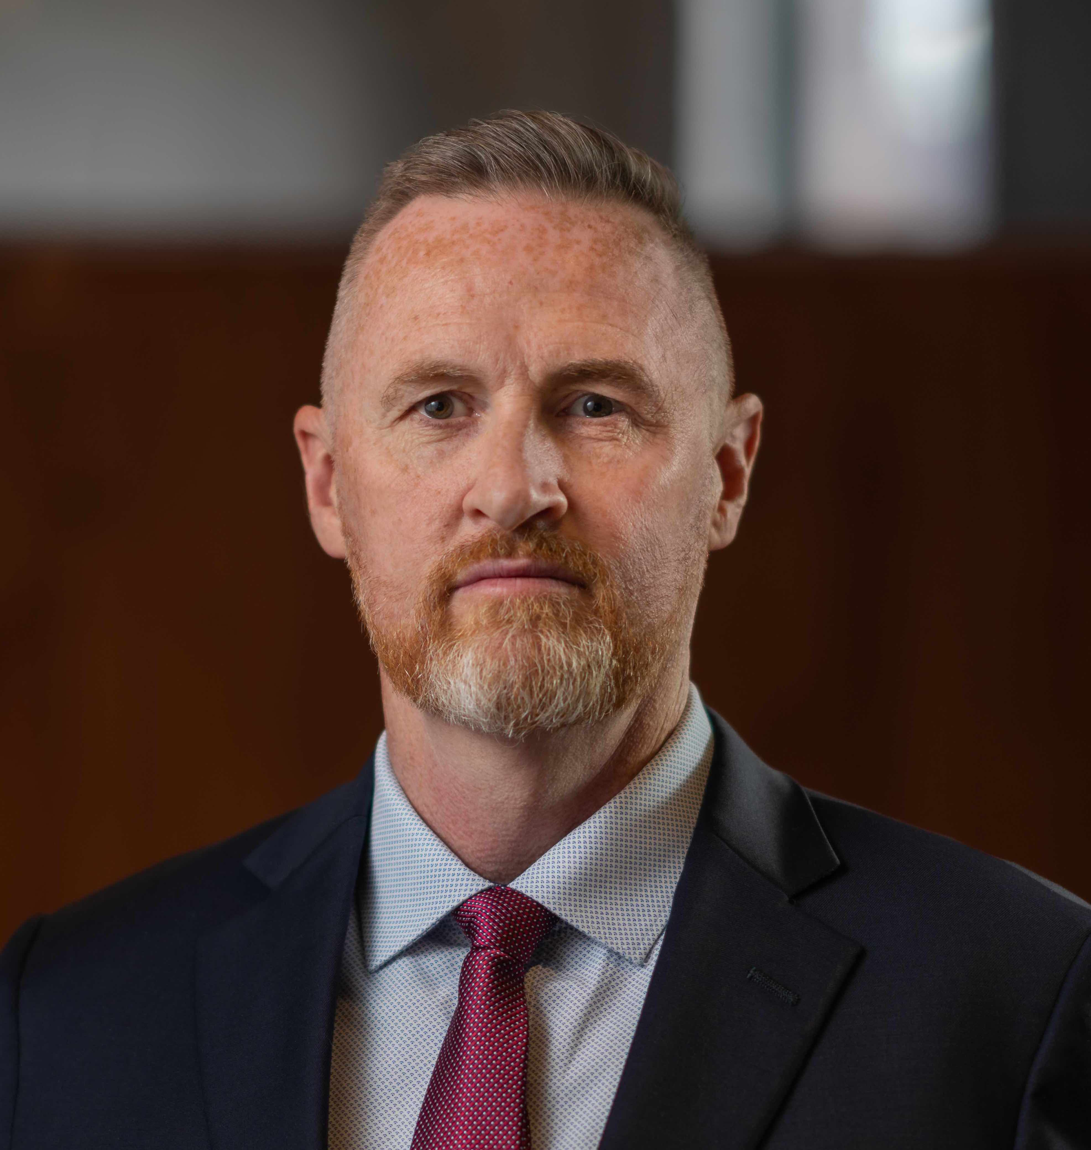
Dr. Ian McCulloh leads the Johns Hopkins University Artificial Intelligence portfolio for Lifelong Learning providing a range of continuing education and customized executive education for both industry and public sector. He maintains faculty appointments in Computer Science and Public Health. His research combines neuroscience, artificial intelligence (AI), and human behavior to develop at-scale AI systems that improve peoples’ access to products, services, and healthcare. He is the author of “Social Network Analysis with Applications” (Wiley: 2013), “ISIS in Iraq: Understanding the Social and Psychological Foundations of Terror” (Oxford: 2023), “Networks Over Time” (Oxford: forthcoming) and has published over 100 peer-reviewed academic papers. Previously, McCulloh served as Accenture’s Chief Data Scientist and managing director of their Federal AI practice which he established and grew to over 1200, delivering some of the most advanced applications of AI and machine learning in use by the US Government, improving speed, equity, and citizen outcomes. McCulloh also served as an associate professor at Johns Hopkins and chief scientist of the Cyber Warfare Systems Group at the University’s Applied Physics Laboratory. McCulloh retired as a Lieutenant Colonel from the U.S. Army after 20 years of service with expertise in social network analysis, special operations and improvised explosive device forensics. During his military tenure, he founded the West Point Network Science Center and created the Army’s Advanced Network Analysis and Targeting (ANAT) program. In addition, he was the chief strategist for information warfare at U.S. Central Command (CENTCOM) where he led interdisciplinary teams of scientists to conduct global, data-driven, social science research to inform strategy for countering extremism and assessing military operations. McCulloh holds a Ph.D. and Master’s degree from the Carnegie Mellon University School of Computer Science, Masters degrees in Industrial Engineering and Applied Statistics from the Florida State University, and a Bachelor’s degree in Industrial Engineering from the University of Washington. He is married with four children and one grandchild.

